Introduction
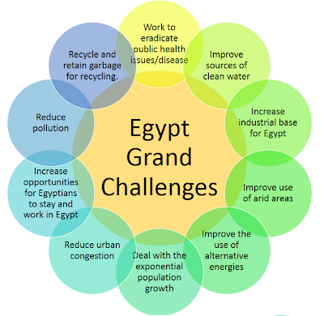
Egypt suffers from many economic, political, and industrial problems. 11 of these problems are the greatest and the hardest for Egypt to solve, which is why they’re Egypt’s 11 grand challenges as shown in Figure 1.
First, population growth. It’s a problem that drives Egypt to higher agriculture consumption rates. Second, Recycle Garbage and Waste for Economic and Environmental Purposes and its consequences. A problem that damages Egypt’s economy and resources. Third, Address and reduce pollution fouling our air, water, and soil. Many deaths and suffering happen in Egypt due to this problem. Fourth, reduction of industrial and agricultural areas. This problem is one of the reasons for Egypt's poor economy. Fifth, pollution fouls air, water, and soil. An environment destroyer problem that affects Egyptians’ health. Sixth, improving the use of arid areas. A problem that wastes much of Egypt’s land. Seventh, sources of clean water. Another problem that causes many diseases. Eighth, population growth. The biggest problem in Egypt is the cause of most of the grand challenges. Ninth, improving the scientific and technological environment. It’s a problem that affects the future of Egypt. Tenth, the effects of climate change. The problem that is considered the future cause of world end. Last, use of alternative energy. A problem that if solved, a better life awaits all people.
Figure 1 Egypt's grand challenges

Population growth
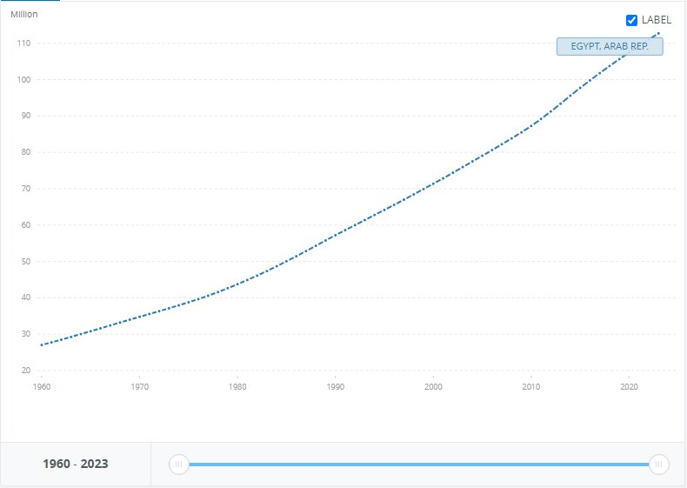
One of, if not, Egypt’s greatest grand challenges is population growth. Over the years, the population in Egypt severely increased with a high ratio, causing huge problems.
As shown in Figure 2, the population went from 27M to 112M in 63 years with a 314% increase in population and 2% growth a year. Birth numbers exceeding deaths’ makes Egypt more and more crowded than ever in each minute passing. So over only 63 years, there are 85M more people living on the same space, resources, food, and national income while a lot of them don’t work because of high unemployment.
Figure 2 Population in Egypt
The reduction of resources and hard life for the individuals living in Egypt are the consequences of population growth. Making it a difficult challenge for Egypt to face.

While some cities in Egypt are the most populated, for instance, Cairo itself is populated with 10% of Egypt’s population, 10,364,881 in numbers. When it’s only 0.3% of Egypt’s total area, equal to 3,085 km^2. Showing how bad the population distribution is in Egypt.
Causes for population growth
1. Early marriage
In the past years, it was a tradition that girls should marry early. Marring at the age of 13 and 14. In the countryside and southern Egypt, it’s considered a shame to reach 20 years old without marriage. Which makes a large number of births in a short period of time. Exceeding deaths and growing population.

16% marry under the age of 18. And 2% marry under the age of 15. This means 1 in 6 women is married before their 18th birthday. In total 8.1M women are wed under 18 to date according to UNICEF. 15.8% of child prevalence in Egypt in 2021.

2. Bad population distribution
Egypt’s area is 1002000 KM^2, however, only 105199 KM^2 is inhabited by people. Most of the population is around the Nile banks leaving large arid areas in Egypt, and urban congestion in all populated cities. While the population grows. The population in Egypt centered in Cairo and Giza. There are 18.73% of Egyptians only in these two cities. 10,365,881 Egyptian and 9,663,702 in Giza of 106,890,565 according to the Central Agency for Public Mobilization and Statistics.
3. Poverty
27% of Egyptians were below the poverty line in 2023. Poor people marry early and give birth in large amounts, hoping their children will take care of them although, increasing population growth and the poor.
The current fertility rate for Egypt is 3.097 births per woman. Approximately 10M children live in poverty in Egypt, nearly 3 in 10 children and 28.8% of children live in extreme poverty according to UNICEF.
Impacts of population growth
1. Pollution
Population growth increases pollution severely. Egypt is ranked 9th in air pollution. And Egypt holds the 12th position in the global pollution index, with a score of 82.7 making it one of the most polluted countries in the world. Emissions from vehicles, industrial processes, and agricultural activities are the reasons for high pollution levels.
2. Economic pressure
Egypt’s spending in 2023/2024 reached 3 trillion EGP. Marking a 34% increase from the previous year. And the more population growth the more money Egypt needs to provide essential needs for its civilians. While Egypt’s revenue for the year 2023/2024 is only 2.14 trillion EGP, putting Egypt under high economic pressure.
3.Housing shortages:
The rapid growth in population in Egypt caused a horrible experience for its people. The housing shortage is a problem that Egyptians face because of the population growth. Poor families are the most affected by this problem as according to a research paper done by the CIA, formal housing stock grew from 1.8M to 2.1M in 25 years, and in those years, urban households grew from 2M to 4.5M. It means that a lot of Egyptians are endangered to be homeless.

Recycle Garbage and Waste for Economic and Environmental Purposes

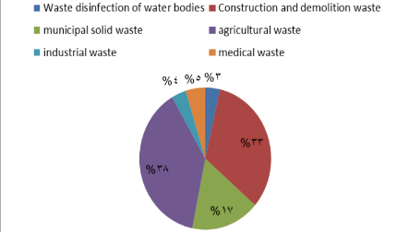
Egypt is a large African country that lies in the Middle East. In the last few years, Egypt has faced a hard, grand challenge that affects Egyptians’ daily lives. Which was pollution. Pollution has been prevalent in Egypt, especially in known regions such as the Nile Valley region. Egypt’s environment has been exerted gloomy influence by pollution. Also, Egypt is producing 75 million tons of various types of solid waste annually, as shown in Figure 3.
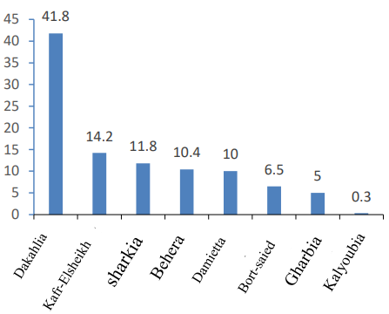
Egypt has tried to commence it by working for the safe disposal of waste and garbage, which causes this pressing problem. The Most effective way for the Egyptian government and the Egyptians is to recycle the garbage and wastes. The A.P.E )Environmental Protection Association) in cooperation with The EISWR (Enhancement of Integrated Services Promotion and Waste Recycling Company), was addressing the garbage and pollution problem in Egypt through many approaches to recycling the waste. Nevertheless, pollution is rising day by day.
Figure 3, Egypt Production of urban solid waste
Amounts of garbage are getting high levels on the streets and public areas, waste is becoming more ubiquitous in the governorates, and nature is damaged because of this. For example, there are 635.224 tons per year of garbage in Assiut Governorate is collected. Also, there are amounts of agricultural garbage generated by some governorates have reached 3.6 billion tons in 2020, as illustrated in Figure 4. In addition to that, there are around 4 billion cubic meters of agricultural and industrial raw sewage dumped per year in the Nile River. They contain acids, organic compounds, pesticides, inorganic nutrients, etc.; all of them are contaminating the river and decreasing the WQL (Indices of Water Quality), as shown in Figure 5.
Figure 4, Percents of agricultural garbage amounts generated in these governorates in 2020

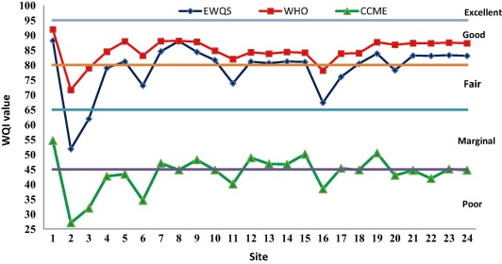
Recycling is a perfect way to solve pollution with its forms, like water pollution in the Nile River, the Red Sea, and some of the oases. And agricultural problems. But Egypt’s government hasn’t worked better on it.

Causes:
- Growth and population crowding
Figure 5, Levels of WQL in Nile water
Egypt’s population equals to around 106 million people in the middle of 2024. That means there is a lot of garbage. The population in Egypt is increasing dramatically per year. There’s a relationship between the increasing population and the effect of the environment which is a significant issue. For example, most governorates to produce garbage in 2022 were the most crowded governorates with a population like Cairo with 23.3%, Giza with 10,4%, and Qalyuobia with 6.4% of all Egypt production of garbage that reached 76.6K tons per day.
- Egyptian Industrial Sectors
In Egypt, the industrial sectors significantly contribute to environmental problems, which especially affects negatively on the agricultural soil and water quality. As the 2021 report from the Egyptian Environmental Affairs Agency (EEAA) said, over 60% of Egypt's industrial waste is inadequately treated. The thing leads to that soil is polluted. In addition to that, the Egyptian Ministry of Water Resources and Irrigation has reported that about 30% of industrial wasted water is discharged without treatment into the Nile River, which spreads water pollution. Additionally, there are around 22 million tons of solid waste per year according to the Solid Waste Management Regulatory Authority (WMRA). Also, the amount of untreated or partially treated industrial pollutants that enter the water supply is estimated at 4.5 million tons per year. Because of that, there isn’t effective waste management in Egypt, there are around 28% of waterways cleaning waste, 1% hazardous waste, 1% medical waste and only 5% of waste from the industries are generated, although the industrial sectors are the main cause of most of these amounts.
- Inefficient Waste Management Policies
Egypt's increasing garbage problem is mostly caused by ineffective waste management regulations. A large portion of waste ends up in open spaces or illegal dumpsites due to improper collection and disposal caused by unclear regulations and enforcement. For example, a significant amount of municipal solid waste goes uncollected, with only roughly 60% of it being formally collected. Cities like Cairo and Giza struggle to handle their enormous daily waste output due to inadequate infrastructure and funding. Furthermore, depending too much on the unregulated recycling industry, which manages 80% of recycling, leads to inefficiencies and environmental risks. These disparities cause serious pollution, which lowers the quality of the air, water, and soil and raises health risks in low-income areas. Putting in place contemporary waste management systems,
Impacts:
- Healthy Impacts
The amounts of garbage and wastes which are not generated well in Egypt areas and regions have severe health impacts. Poor waste management is reason for pollution in water sources, increasing the prevalence of diseases as like cholera and typhoid, especially in low-income areas. The World Health Organization (WHO) has reported that waterborne diseases affects on 20% of hospitalizations in Egypt. In addition to that, around 50% of children in Egyptian slums are suffering from diarrhea because of untreated waste and unsanitary conditions in these areas. To add, a report says that 38 million people drink polluted water from Nile and other resources. It pointed out that the high rates of poisoning cases are caused by pollution from the different cities of Egypt. On water, around 100,000 people are diagnosed by injuring with cancer per year because of waste in water.
- Economic Impacts
Egypt generates about 75 million tons of waste annually, according to AUC Knowledge Fountain report in November 2021. With 22 million tons of municipal solid waste. The illegal handling of these amounts of waste costs the economy around 1.5% of the GDP because of the health impacts and the loss of tourism. For instance, Egypt loses about 100 million dollars annually due to the environmental degradation in tourist destinations in the country. Also, a statistic approved that 2.8 million metric tons of plastic waste were leaked into the Mediterranean each year, and Egypt is by far the largest source, accounting for 43% of the total, according to the Worldwide Fund for Nature (WWF). The informal recycling sector accounts for 80% of recycling efforts but lacks regulation. Additionally, a study reported that the GDP is lost in Egypt by about 5.7 billion dollars per year due to non-recycled waste.
- Environmental Impacts
The over-increased amounts of garbage in Egypt severely harm the environment. There are large amounts of garbage that remain uncollected, especially in rural areas where collection rates are as low as 0–35%. This waste is leading to severe land and extensive pollution of the Nile River and other water bodies as lakes and Egypt's two seas. Also, roughly 56% of this waste is accounted for as organic waste, which contributes to high methane emissions when it decays and worse changes in Egypt's climate and weather. For instance, Egypt contributes around 1.5 million tons of plastic waste annually in coastal areas; most of these amounts lay and end up in the Mediterranean Sea according to the Worldwide Fund for Nature (WWF). In addition to that, about 40% of garbage in cities such as Cairo is uncollected, which affects solid health and leads to land pollution threatening biodiversity.

Address and reduce pollution fouling our air, water, and soil
Pollution has been a serious danger in the last decades, threatening the fate of humans all around the globe. Egypt, being one of the most crowded countries in Africa, it is one of the most countries affected by pollution. Doesn’t it affect only people, but pollution also destroys crops, kills marine creatures, and destroys whole ecosystems. Reported by the ECESR, unsafe drinking water and poor sanitation contribute significantly to kidney and liver diseases, schistosomiasis, and diarrhea. WHO estimated 5.1% of deaths and 6.5% of disabilities to be caused by those factors.
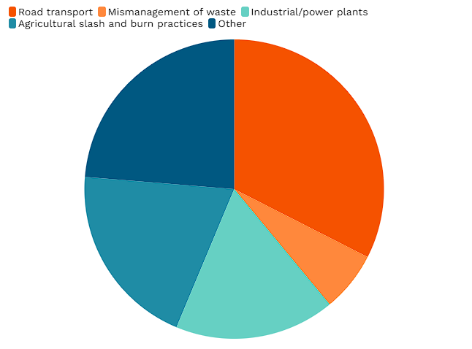
Cairo stands as the most pollution-afflicted governorate in Egypt, grappling with severe levels of air, water, and solid waste contamination due to its high population density, concentrated industrial activity, and inadequate waste management infrastructure. The annual nationwide average PM2.5 concentration in 2019 was 13.6 times greater than WHO 2021 recommended concentration levels. As demonstrated in Figure 6, road transport is the most prominent causative of PM in Egypt. This makes densely populated cities more vulnerable to pollution, placing Cairo at the top of the list of Egypt’s most polluted cities, followed by Giza and Qalyubia.
Figure 6: Major factors of PM in Egypt

Causes:
- Vehicle emissions
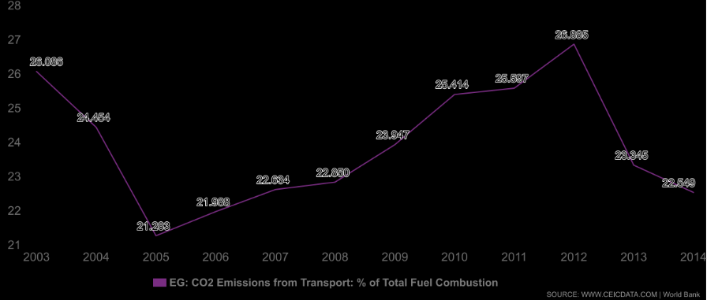
Road emissions have been the main factor of pollution in Egypt, causing severe damage to both individuals and the government. The primary source of PM2.5 air pollution in the greater Cairo area is road transport, accounting for a devastating 33% of the total. This is caused by aging private cars and taxis, which account for 80% of the extreme congestion problem. Traffic volumes can reach 7,000 vehicles/hour per lane, far exceeding the maximum theoretical flow of 1,900. As shown in Figure 7, emissions from transport (primarily cars) continued to increase from 21.2 MtCO2 in 2005 to nearly 27 MtCO2 in 2012, showing the severe damage cars and transport can cause to our air.
- Industrial effluents and heavy metals
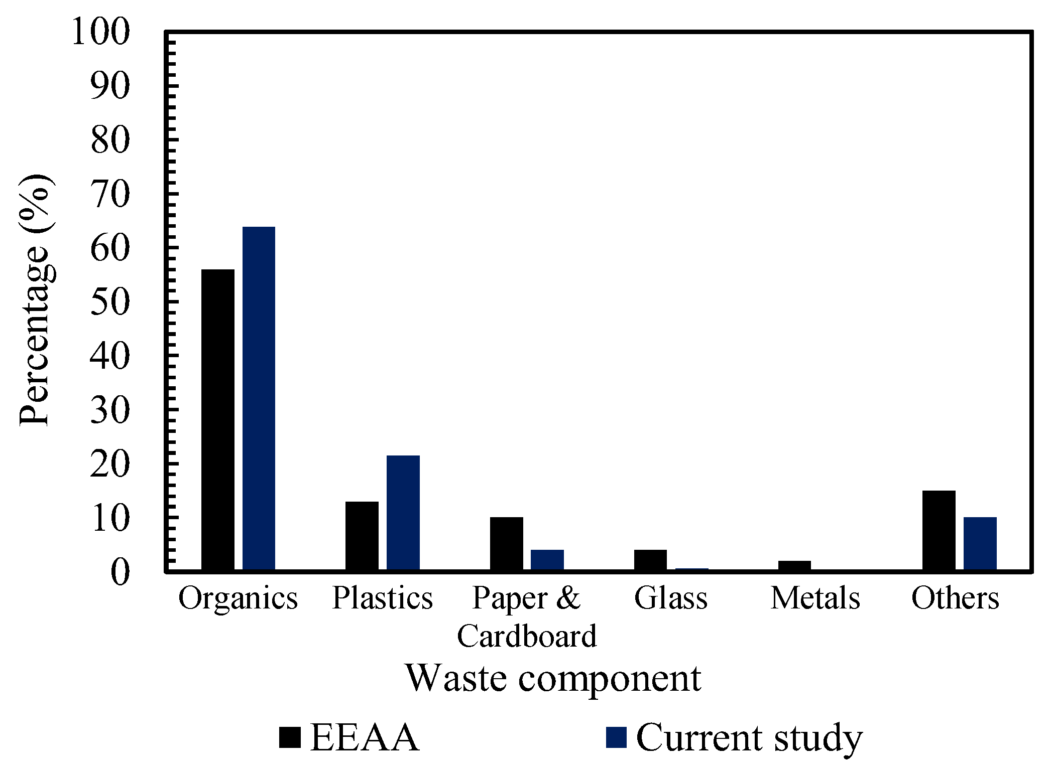
Industry is one of the pillars of our modern life, but it is also a major cause of pollution. Reported by the water research and pollution control department in Cairo, about 350 factories dump wastewater directly into the Nile or through drains; Alexandria alone contributes around 60% of the coastal marine pollution via 1250 plants discharging into Lake Mariout. As represented in Figure 8, EEAA and current studies report that large volumes of plastics and heavy metals persistent organic pollutants (PCBs) have been tracked across the Nile, meaning that they’re a serious cause of water pollution for Egypt, especially the Nile.
Figure 8: Comparison between the waste composition in Cairo (current study) and the generalized composition in Egypt issued by the Egyptian environmental affairs agency
Figure 7: Egypt road transport emissions 2003-2014
- Atmospheric Deposition & Dust
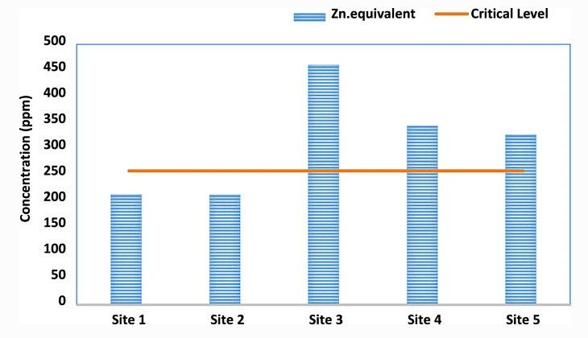
According to Assiut University, industrial dust from mining and factories carried by wind deposits heavy metals like Cd, Cu, Pb, and Zn on soils. As shown in Figure 9, Zn equivalent concentration already surpasses the critical level in 3 of 5 sites. According to the Egyptian Journal of Chemistry, a survey in Sinai and Ismailia found 20 pesticide residues, with total soil concentrations of 0.505 mg/kg in South Sinai, 0.075 mg/kg in North Sinai, and 0.207 mg/kg in Ismailia.
Figure 9: Zn equivalent measured in 5 different sites
Impacts:
- Health Impacts – Leading Cause of Premature Deaths
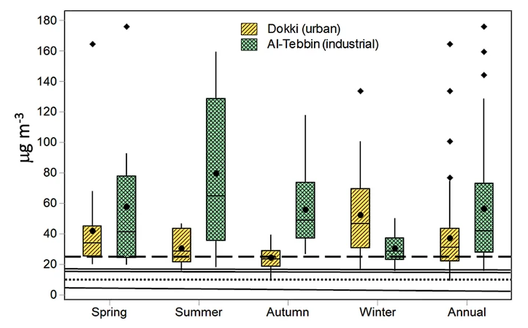
Air pollution has many severe and widely recognized impacts. The most recognized one of all is its impact on public health. As shown in Figure 10, all the measurements of PM_{2.5} exceed even the WHO annual guideline of 10 µg/m³, highlighting persistent overexposure for Cairo residents, resulting in chronic health burdens like respiratory and cardiovascular diseases. According to the WHO, in 2023, 49,756 deaths in Egypt were due to ambient particulate matter (PM) pollution; an additional 3,452 deaths from household air pollution, totaling around 53,200 deaths.
Figure 10: Box-and-whisker plots show higher PM₂.₅ concentrations in industrial zones (Al-Tebbin) versus urban residential areas (Dokki), across seasons.
- Human Health Risks Beyond Fish Consumption
In the Nile Delta, shallow aquifers are contaminated by nitrates, pesticides, and heavy metals. Residents using irrigation canals for drinking water increased rates of kidney, liver diseases, and even pancreatic cancer, especially in northeastern Delta villages. Water pollution also contributes to waterborne and microbial diseases, as El-Batts drains and Fayoum irrigation canals show high fecal coliform levels (up to hundreds of thousands CFU/100 mL), especially in summer, contributing to intestinal helminth infections and diarrheal illness.
- Contamination Hotspots & Ecological Risk
In El-Minia (near El-Moheet drainage), soil is contaminated by Zn > Cr > Cu > Pb > Co > Cd, with 70.7% of the area showing “considerable” contamination, Cd being the most severe. Fayoum’s Eastern area shows very high ecological risk from Cd (risk index ~4,157), moderate risk from Pb (~51), and lower risks from Ni and Mn. While adults have a non-carcinogenic hazard index (HI) below safety (<1), children exceed it (HI >1), with carcinogenic risks from Cd, Ni, Pb above acceptable levels (>1×10⁻⁴).

